**Project Id: PNT2022TMID23080**

**Project Name: AI-powered Nutrition Analyzer for Fitness Enthusiasts**

Technical Stack:

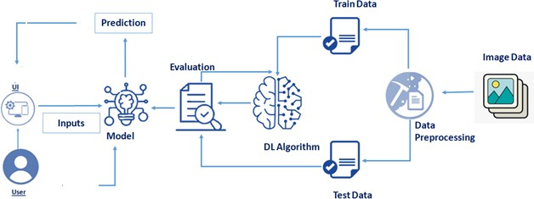

|  |  |  |  |
| --- | --- | --- | --- |
| S.No | Component | Description | Technology |
| 1. | User interface | How user interacts with application e.g.  Web UI, Mobile App, Chatbot etc | HTML, CSS, JavaScript / Angular Js / React Js etc. |
| 2. | Application Logic-1 | Logic for a process in the application | Java / Python |
| 3. | Application Logic-2 | Logic for a process in the application | IBM Watson STT service |
| 4. | Application Logic-3 | Logic for a process in the application | IBM Watson Assistant |
| 5. | Database | Data type, Configurations etc. | MySQL, NoSQL, etc. |
| 6. | Cloud Database | Database service on Cloud | IBM DB2,IBM Cloudant etc. |
| 7. | File Storage | File storage requirements | IBM Block Storage or other Storage service or Local Filesystem |
| 8. | External AP-1 | Purpose of External API used in the application | IBM Weather API, etc. |
| 9. | External API-2 | Purpose of External API used in the application | Aadhar API, etc. |
| 10. | Machine Learning Model | Purpose of Machine Learning Model | Object Recognition Model, etc. |
| 11. | Infrastructure (Server / Cloud) | Application Deployment on Local System / Cloud  Local Server Configuration:  Cloud Server Configuration : | Local, Cloud Foundry, Kubernetes, etc. |

**Table-2: Application Characteristics:**

|  |  |  |  |
| --- | --- | --- | --- |
| S.No | Characteristics | Description | Technology |
| 1. | Open-Source Frameworks | List the open-source frameworks used | Technology of opensource framework |
| 2. | Security Implementations | List all the security / access controls implemented, use of firewalls etc. | E.g. SHA-256, Encryptions , IAM controls, OWASP etc. |
| 3. | Scalable Architecture | Justify the scalability of application (3 – tier, Micro-services) | Technology used |
| 4. | Availability | Justify the availability of application (e.g. use of load balancers, distributed servers etc.) | Technology used |
| 5. | Performance | Design consideration for the performance of the application (number of requests per sec, use of Cache, use of CDN’s) etc. | Technology used |

**References:**

[**https://c4model.com/**](https://c4model.com/)

[**https://developer.ibm.com/patterns/online-order-processing-system-during-pandemic/**](https://developer.ibm.com/patterns/online-order-processing-system-during-pandemic/)

[**https://www.ibm.com/cloud/architecture**](https://www.ibm.com/cloud/architecture)

[**https://aws.amazon.com/architecture**](https://aws.amazon.com/architecture)

[**https://medium.com/the-internal-startup/how-to-draw-useful-technical-architecture-diagrams-2d20c9fda90d**](https://medium.com/the-internal-startup/how-to-draw-useful-technical-architecture-diagrams-2d20c9fda90d)